Bournbrook & Varsity Medical Centre- Additional Questions
Marital Status: Single/ Married/ Widowed/ Divorced
Occupation: ………………………………………………………………………
What is your first language? …………………………………………………….
What Language(s) do you write? ……………………………………………….
What religion do you consider yourself to be? ………………………………..
What is your exercise grading?
Low activity – no organised exercises or regular sports
Medium activity – regularly exercises for pleasure on a weekly basis
High activity – takes fitness training and/or plays for recognised team or competes in athletics events
Family Medical History: Does anyone in your close family (i.e. mother, father, brother, sister) have any medication problems? If so, please state which ones.
Relation: ……………………………………………… Condition: ………………………………………………..
Relation: ……………………………………………… Condition: ………………………………………………..
Alcohol: Please indicate if you would like an appointment with our Healthcare Assistant to discuss your alcohol intake. I do want alcohol intervention I do not want alcohol intervention

New Patient Health Check
All new patients registering with this Practice are eligible for a New Patient Health Check with our Health Care Assistant. Please book an appointment for this at Reception in the next 6 weeks or tick the box below if you do not want a Health Check:
I do want a New Patient Health Check I do not want a New Patient Health Check

Communication consent
Please indicate how you preferred to be contacted:
SMS (including text appointment reminders) Accept Decline
Email: Accept Decline
Telephone: Accept Decline

Reasonable Adjustments
If you have made us aware of any reasonable adjustments, are you happy for this to be shared with other organisations in the NHS and social care that will be involved in your care?
Yes No

Failure To Attend Appointments
The practice follows a policy for patients who fail to attend appointments. All appointments not attended will be recorded on your medical record. Your GP will discuss these with you and they have the right to remove you from the Practice if you repeatedly fail to attend.
KEEP IT OR CANCEL IT! Please tick here to confirm you have read this section:

NHS App
Sign up to online services to manage your appointments, order repeat medications, view test results, vaccination history and access your medical records.

Sexually Transmitted Infections Self Sampling Kits
Chlamydia is a sexually transmitted infection. If you are aged between 16 to 24 and are sexually active you are invited to complete a test –It’s all confidential and you can do it at home if you want.
You might not even know you have Chlamydia as often there are no signs or symptoms. 1 in 10 people under the age of 25 have Chlamydia and it can be easily treated with antibiotics.
I have taken a kit from the Practice I do not wish to take up the offer of a free chlamydia test

Patient Participation Group - PPG
The practice has an active patient participation group who are here to represent the views of the Practice’s patients. We hold quarterly meetings that we hold at the Practice. Your feedback will help set Practice priorities for the future. We look at many aspects of Healthcare, but in particular, the services we provide.
If you would like to become a member of the PPG please tick the box below:
I do want to be part of the PPG I do not want to be part of the PPG

Practice Newsletter
If you would like to receive a copy of our quarterly newsletter via SMS or e-mail please indicate here:
I do want to receive the Practice Newsletter: Via E-mail…………………………………………………..
Via Mobile Phone…………………………………………
I do not want to receive the Practice Newsletter:

Let us know your Immunisation Status
Have you recently arrived in the UK? Please let us know what vaccinations you have had in your home country, this will help us to know if you require further vaccines to bring you in line with the National Immunisation Schedule for the UK. These vaccines are free of charge. It is important that you keep up-to-date with vaccinations to prevent outbreaks of diseases such as Measles and Hepatitis A.
Please tick here to confirm you have read this section:

Meningitis ACWY & MMR Vaccination for new students
As you may be aware there has been a small increase in the rate of meningococcal meningitis or septicaemia in recent years. It is still an uncommon condition but young people attending higher education for the first time, especially when living in halls of residence or other shared accommodation, are at greater risk of this disease particularly in the first few weeks of their first term at university. Meningitis ACWY immunisation is part of the UK immunisation programme however ALL students should check their immunisation records to ensure that they have received it since their 10th birthday.
Department of Health advice is that all those entering higher education should have had two immunisations against measles, mumps and rubella (known as MMR). To achieve maximum protection you should have been immunised against Meningitis ACWY and MMR before attending the University, but if you have not had it we urge you to book an appointment with the Practice Nurse.
Please tick here to confirm you have read this section:

Latent Tuberculosis Testing
If you are aged 16 to 35 years old, arrived in the UK in the last 5 years and have never been screened or treated for TB in the UK you may be eligible for a Free Latent TB blood test.
- Were you born in a country with a high risk of TB?
- Or, Have you spent more than 6 months in a country with a high risk of TB within the last 5 years?
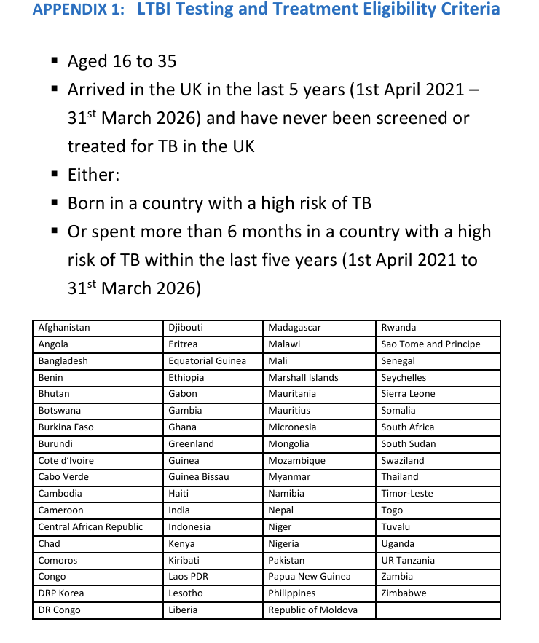
I meet the criteria above and would like to be invited for a Latent TB blood test

Are you a Migrant to the UK?
We can arrange an initial health assessment for you if you have health conditions or circumstances that you would like to discuss further with a Doctor.
If you are interested in booking a Migrant Health Assessment we will provide you with an additional questionnaire to complete before your appointment.
I do want a Migrant Health Assessment I do not want a Migrant Health Assessment
Opt Out Form for Sharing Data from your Medical Records
There are several data sharing projects currently in progress and these are:
- SCR – Summary Care Record is a national database that holds basic information such as current medication and allergies, this can be seen by authorised staff in the health care system who are involved in a patients direct care, for example by emergency services.
- Birmingham & Solihull Shared Care Record allows local NHS services to view your records from all of the different organisations who are involved with your care. To find out more or opt out of this please complete the ‘right to object’ form at www.birminghamsolihullics.org.uk/our-initiatives/shared-care-record
- National Data Opt Out Service allows patients to opt out of their confidential patient information being used for research and planning. We cannot opt patients out this has to be done by the patient themselves. For more information visit: https://digital.nhs.uk/services/national-data-opt-out

It is important to note that each of these projects run a separate opt out system. Therefore if you wish to opt out of the Summary Care Record please complete the form below and return to us. For the other record sharing schemes please opt out using the website details given above or speak to us for further details if you do not have internet access.

SCR - Summary Care Record:
Used in emergency care this record will contain information about any medicines you are taking, allergies you suffer from and any adverse reactions to medicines you have had, to ensure those caring for you have enough information to treat you safely.
SCR – Accept this Service
SCR - Decline this Service (9ND0)
More detailed information about these projects can be found in main reception and also on our website.
Print Name:…………………………….. Signature: …………………………. Date: …………………….

